**Session8-----Process Management Commands**

**ps------**To display the current process running

**kill-----**Kill the process

**top----**Display Linux tasks

**sar----(**System Activity report): It is used to collect the CPU, memory and i/o usage

* Suppose we are executing any Linux command or any shell script it is going to generate one process id for each task or for each command. To check that process id ps is the command.

**ps**---after executing this below is the screenshot

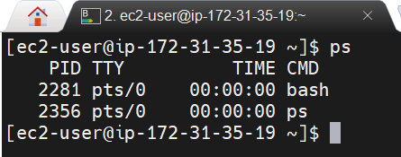

PID -Process ID, TTY – terminal, CMD – command

**ps -ef**---if we execute this command, it will give detailed information (here e means details of all the process in that particular user info and f means in the formatted way it is going to display as below

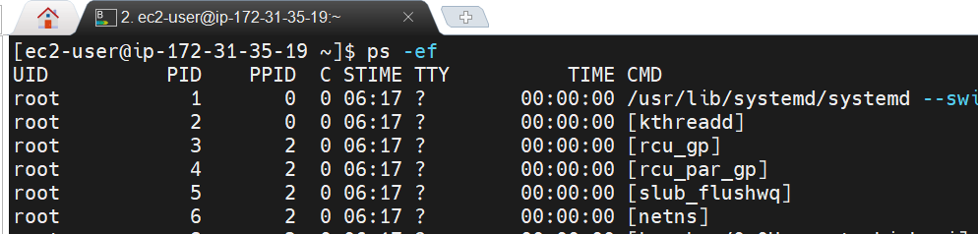

Here UID---User ID, PID – Process ID and this pid is going to create uniquely for each task, PPID – Parent process ID, ……….

* Assume suppose we install Jenkins service then service is going to create and it is going to create on process id for that service. And we need to stop that service we are using the below commands.

**systemctl option(start|stop|restart) servicename**

**service servicename option(start|stop|restart)**

* By using above commands, we are trying to stop the service but it is not stopping, then what to do we need to kill the process id. But before killing the process id we need to get the process id for that particular service or for the particular command. Below is the command to kill the process.

**kill -9 PID** (process id)-🡪here (-9 is the signal to kill the process which we have given and we have so many signals in the kill command to check that command is **kill -l**)

By default, if we connect any server (for ex I have connected to ec2 server which I have launched in AWS then below bash shell will established a connection with one process id and if we connect to any server or by default bash shell connection will establish. Every time we are connecting and it will establish a new bash with new process id for that bash (here bash is nothing but shell). Below is the screen shot of bash i.e. shell with its process id.

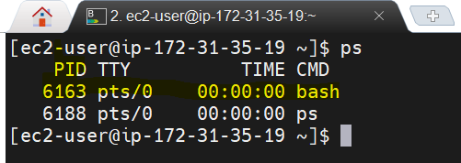

These generated process ids are not for servers. This particular PID’s are for users and these PID’s are generating for users within the server but for each user various PID’s are going to generate based on what software’s you are running and what commands u are running.

**Kill -9 6163**---It will stop the connection or kill the connection for my ec2 server which I have connected as below.

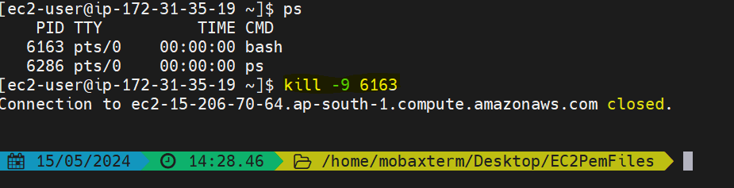

* Now how long the service is running in the server we discussed by using **uptime** command when we are using uptime command it will give how long server is up and running and CPU performance (load average). But it is not giving other resources like Ram and memory for that **top** command we need to use

**uptime**-🡪 if we execute this below is the screen shot

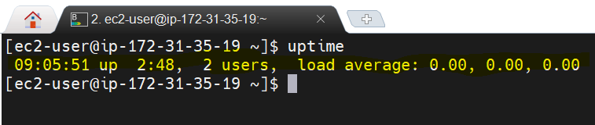

To check the details like Ram and memory we can use **top** command

**top** 🡪 It will give all the server resources how it is utilizing like **%CPU% utilization**, **%MEM%** utilization means RAM utilization, how much time it is up and running, how many users are connected of that particular server which we have connected…….and what are the process id’s and what are the commands and services we have executed and taking more CPU utilization those services will be display on top. See the screen shot below.

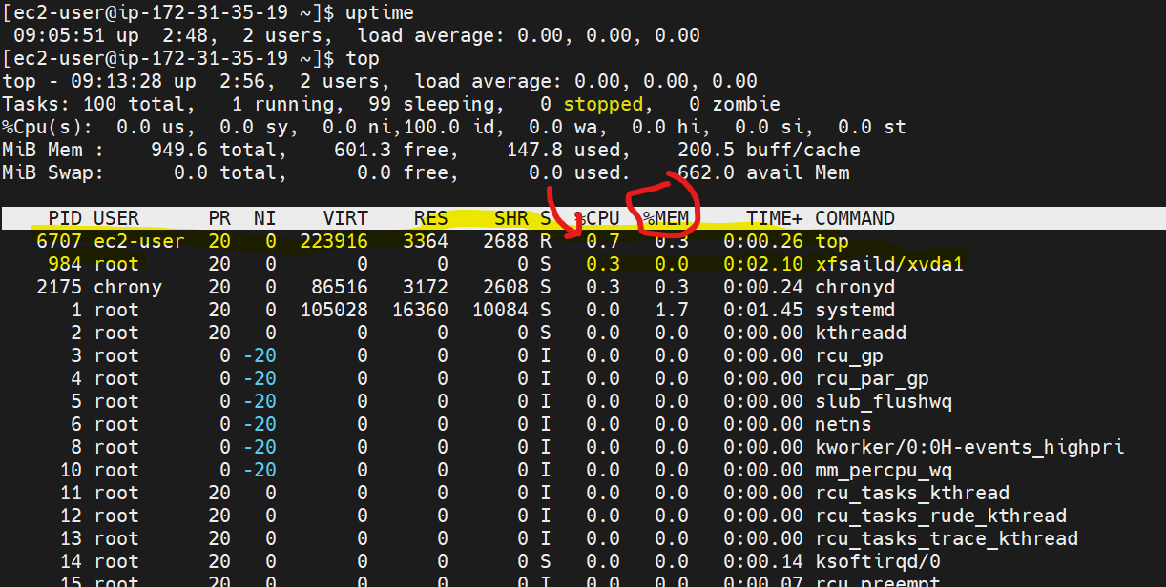

**Note: By using top command, we can see all the resources utilization of that particular server which we have connected. As above. Many times, we are going to use top command. Can you give any real time use case for this. For example, developer pinged and saying your server is not working then how you are going to debug**

**🡪**First, we are going to check hard disk is used 100% or not and it is ok not using 100% but still server or application is down, then how to debug here we are going to check cpu utilization and ram utilization by using top command if both are more then application is not going to work

**Achieve/Data Backup Commands**

**Zip🡪**Package and Compress (archive files)

**Unzip🡪**Extract Compressed files in a ZIP archive

**Tar🡪It is used to archive the directory files**

* If I am having a Jenkins directory with size 10GB and I want to move this file to another server then it will take more time bcz it is having size of 10GB, then I want to compress the size of this 10GB file for this we have an archive related commands like zip and tar.

**zip -r jenkins.zip Jenkins**🡪It will create a Jenkins zip file (here Jenkins is the directory with 10GB file and giving signal as to create Jenkins.zip file). See below

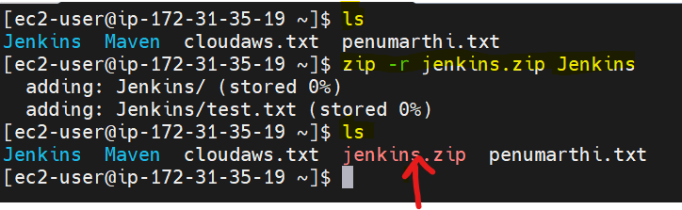

Initially we are having Jenkins, Maven, cloudaws.txt, penumarthi.txt later executed zip command it created Jenkins.zip folder. If we observe that Jenkins.zip file is an archive file that’s why it is showing in red colour.

* To unzip this archives Jenkins folder, we have a command unzip to extract the file

**unzip Jenkins.zip**🡪 It is the command to unzip the archive file (Jenkins.zip is the file name which file need to unzip) But before unzip we need to delete (rm -rf Jenkins) the Jenkins directory before unzip as bcz after extracting it will create again Jenkins directory. See the below screen shot for clarification of steps like rm -rf before unzipping the Jenkins and Jenkins got extracted and Jenkins directory is there.

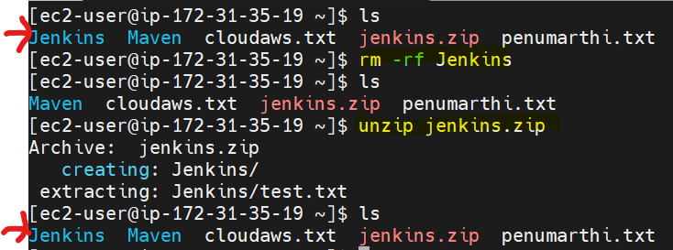

* We have one more command to archive the directory or a file that is tar. Difference between two commands zip and tar both are archive techniques only. But for example, Jenkins directory having 10GB and by using zip it will compress 1GB and by using tar command it will compress more means up to 500MB

**tar -cvf Jenkins.tar Jenkins** 🡪 It will create tar file (here c means create tar file, v means varbos, f means file system)

After that before unzip the tar file we need to delete the Jenkins directory for that

**rm -rf Jenkins**

Now again to unzip below is the command

**tar -xvf Jenkins.tar**🡪 It will unzip the Jenkins directory. Below is the execution process screen shot

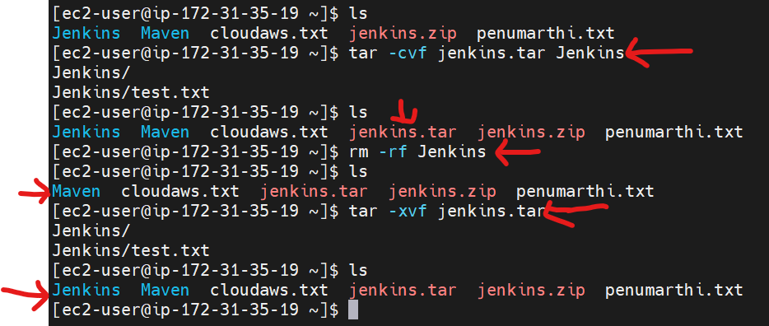

**Note**: Interview point these archive backup commands are important but in real time installing devops software’s we are going to use these archive and backup commands

**User and Group Related Commands**

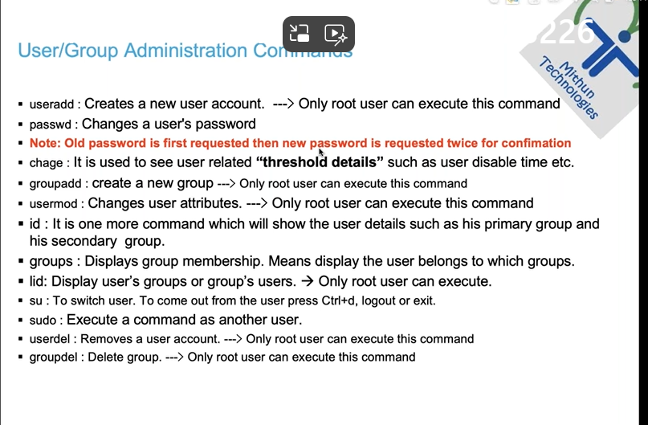

**User and Group Administration commands**

* So far, we are using two users ec2-user/root users (here ec2 user is a normal user and root is the super user or root user)

**useradd bhaskar**🡪It will create one user

Once I created the user what are the things happen in the background all these user information will store in /home directory with the name bhaskar

**/home** (all the user information will store in home directory)

**/etc** and also in etc directory will see some files like shadow/passwd/group (for each user one entry will create in these three files. These three files shadow/passwd/group are used to maintain the user’s information.

Let me create one user

**useradd bhaskar**-🡪It will create user bhaskar if we are in root directory only.

We don’t have a permission to create a user from normal user so switch to root user sudo su – to create the user. See the below screenshot.

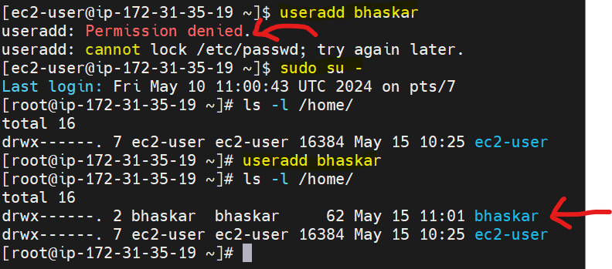

* /home (all the user information will store in home directory)

**ls -l /home/**🡪To check any user information in /home directory

* /etc in etc directory will see some files like shadow/passwd/group and all these three files will maintain user information

**cat /etc/shadow ----- to execute this shadow file only root user can. Or if we want to execute from ec2 user we need to execute with sudo privileges**

**cat /etc/passwd**

**cat /etc/group**

**IQ**) what is the user id UID for root user?

1. 0 is the user id for rootuser

**cat /etc/passwd**🡪 by executing this we can find the UID for root user and in last we can see normal user id UID as well in the below two screen shots

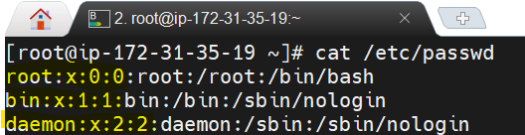

**RHEL 7.x**----RedHat Enterprise Linux version7---Major version, x----minor version

**1000**---default UID for normal users. 1000, 1001, 1002 it is going to create like that from RHEL 7.x version.

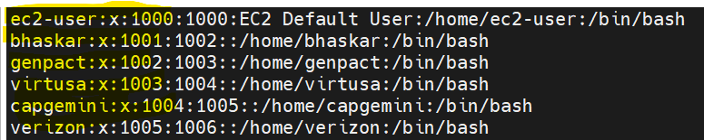

Earlier before RHEL 7.x version UID’s for normal users are generated with 500.

* Now I want to set password for the bhaskar user. Below is the command

**passwd bhaskar**🡪It will ask the password and re-enter the password to conform as below (while giving the password it will not display anything)

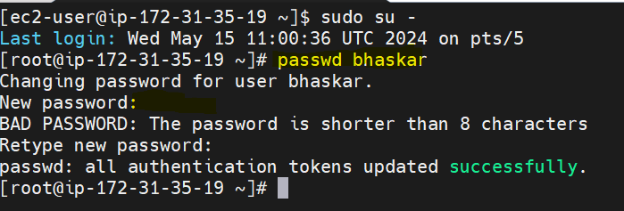

Here where will the password information will store, I mean in /etc/ directory we have 3 files shadow/passwd/group in these 3 in which file password information will store and answer is shadow file password info will store.

**cat /etc/ shadow** 🡪by exec this we can see password info as below screen shot.



In the above screen shot password info is updated for bhaskar user bcz we have set the password. But for ec2-user the password is not set and showing as blank in between two exclamatory mark which is highlighted.

* Now I am updating the password for ec2-user

**passwd ec2-user**-🡪Same process like bhaskar and see the diff in the below screen shot now for ec2-user also password is updated in exclamatory marks



* Can we set the password for root user, yes, we can set the password for root user and we set the password for any of the user like this.

**passwd root** 🡪Again same like giving password and re-entering the password.

We can change password by root user only and after changing the password we can change the attributes and have some limitations like password expiry like max password age, min password age, password expiration like wise. For this we have a command below

**chage bhaskar**🡪after executing this command we can change the attributes and we can set the limitations of password.

* Now I need to create the user, why we need to create the users first of all—to organise the users—we are going to use that group—how we are going to create the groups—by using groupadd command by giving groupname---groupadd DevOps---I want to create DevOps group…Once we created this DevOps group where that group information will be going to store in /etc/group file (cat /etc/group). Here each user is going to consider as a one group. This groupadd also needs to be created in root user only.

**groupadd devops**🡪It will create one group and to see that group

**cat /etc/group**🡪 In this group file we can see the new added group devops.

see below

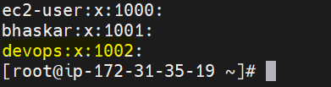

Here one user is treated as one group I mean ec2-user is a group, bhaskar is another group, devops is another group

* Here we are having devops group and bhaskar user. Now we need to add bhaskar user to devops group below is the command.

**usermod -g devops** **bhaskar** (user modification, -g devops means to which group)🡪It will add bhaskar user to devops group.

To check weather bhaskar user is added to devops group or not below is the command

**lid -g devops**🡪it will display weather bhaskar user is added to devops group or not (lid command will not work with superuser privileges it throws an error). See below screenshot.

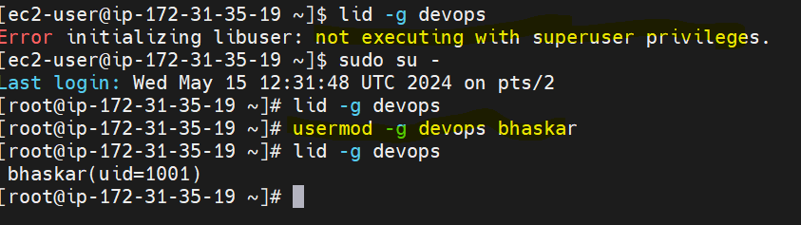

* **Now my requirement is I have a user and I want to know that user belongs to which group.**

**id bhaskar**🡪(id username here username is bhaskar so that bhaskar is represented here) It will give the UID, group ID, user group name as below.

All these details will execute in root directory only

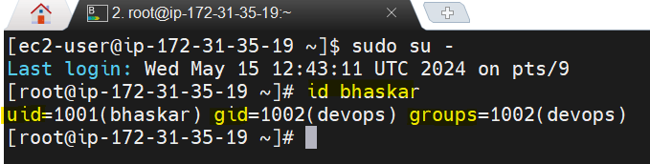

**groups bhaskar**🡪By using this command like groups and specify the username here I used bhaskar as the username it will also display the user belongs to which group

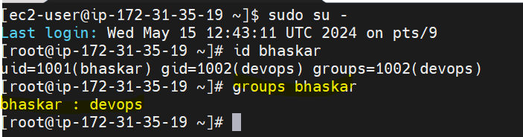

* My requirement is I want to lock one user suppose bhaskar user I want to lock command is **usermod -L username**

**usermod -L bhaskar**🡪 here bhaskar is the user name and this command will lock the bhaskar user.

Before executing this see the bhaskar user details with password for reference with

**cat /etc/shadow** command we can see below is the screen shot and for bhaskar user before $ symbol we don’t have any means the user is not locked



After executing

usermod -L bhaskar🡪It will lock the bhaskar user and see the below screen shot for reference that before $ we have a ! symbol that is the indication that user bhaskar is locked

After executed usermod –L bhaskar execute cat /etc/shadow and u can see the difference in below screen shot for the user bhaskar is locked or not.



Note: If the user having correct username and password also and we have locked the user with usermod –L bhaskar then we are not able to login with the credentials.

If we want to unlock the bhaskar user command is

**usermod -U bhaskar**🡪It will unlock the bhaskar user here u means unlock.

Note: 1) If we are in a root user and want to change the user password then execute the below command and it will ask to enter the new password directly and it will not ask current password in root user

2)If we are executing the command to change the user password in normal user then it will ask the current password and then it will ask new password to change.

passwd bhaskar🡪It is the command to change the user password (bhaskar is the user)

**Note**: one way is if we forgot the password then we need to contact with Linux Admin to reset the password

Second way is If we forgot password for any user the process to reset the password is login to the server and go to root directory by **sudo su –** command and execute

**passwd username** then it will not ask any old password it will directly ask u enter new password and then renter the new password it will update.

We can reset the password or any user like ec2-user, root user and we can reset the new password

**passwd root**

**passwd ec2-user**

**passwd bhaskar**

**Note: All these user/group administration commands will execute from root directory only (only root user have access to do this all activities). Or else if we want to execute from ec2-user and by default we have root permission to ec2-user we need to add sudo while execution the command.**